**FUNCTIONALITIES OF TCP**

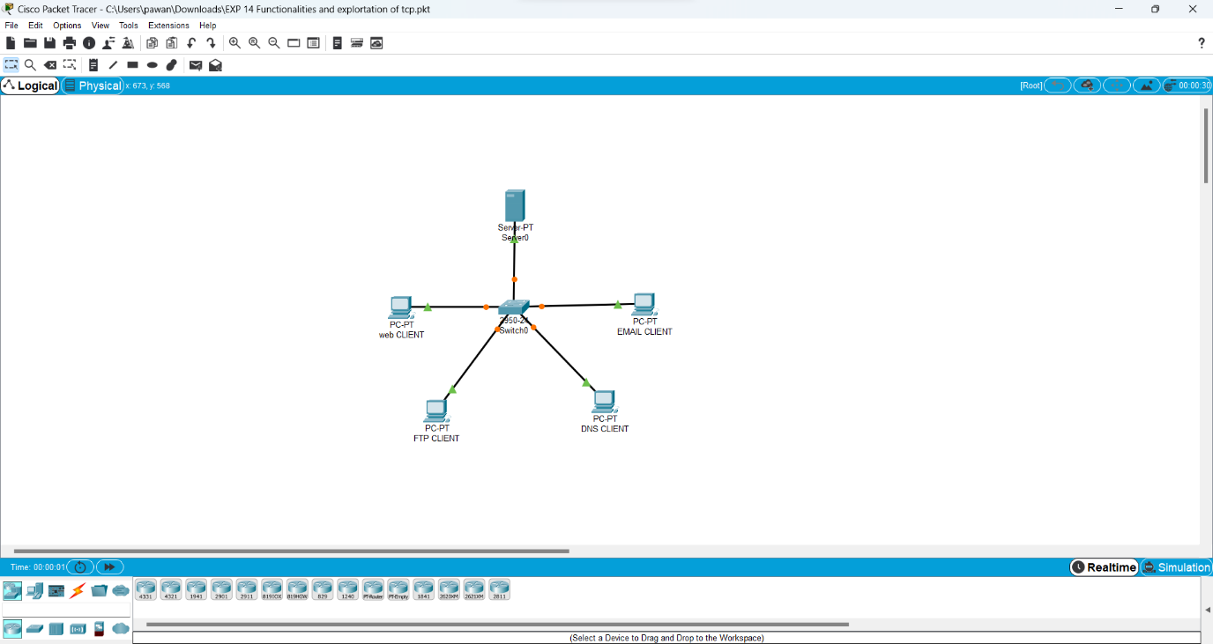

**FUNCTIONALITIES OF TCP**

